Student Leadership Application Packet for 2013-2014


ABOUT THE POSITIONS
Student Leadership positions are available for the Arts, Lectures and Activities Board; Student Fee Board; Communications Board; Student Cabinet and the Research and Advocacy Board. Each of these branches of Student Leadership serves a unique and essential role in representing North’s student body. Students in these positions work with college administrators, faculty, and staff on committees and initiatives that guide and direct college operations. Student Leaders gain resume-building work experience and professional contacts that may provide references for future college and job applications. Student Leaders are expected to represent the concerns and perspectives of North’s diverse student body. Throughout the year, the college administration seeks Student Leader input and guidance for making significant decisions on college operations and policies. For those who have initiative and the ability to collaborate with a team, these Student Leader positions provide ample opportunity to learn, grow and develop professional work skills, competencies and confidence.
- Number of hours range from 2 to 10 per week
- Compensation: $10.83 / hour
- Commitment / Employment Term : September 10, 2013 thru June 15, 2014

IMPORTANT APPLICATION DATES
July 24 Application deadline for guaranteed consideration
*Please detach pages 5-6 from this packet and attach them to your application to be turned in to the Student Leadership and Multicultural Programs CC1446 (behind the Espresso Lounge)*
July 29 – 31 Applicants notified on whether they will be interviewed and at what times
August 5 – 8 Applicant interviews occur
August 12 Applicants notified on position offer or denial
August 16 Deadline for applicants to accept offer
Sept. 10 – 12 Mandatory Orientation / Training (9 a.m. to 4 p.m.)
Sept. 16 – 20 Mandatory Orientation / Training (9 a.m. to 4 p.m.)

PACKET CONTENTS | PAGE
About the Positions & Important Application Dates | 1
Student Leadership Overview & SAC | 2
Available Positions: Job Descriptions & Eligibility Requirements | 3
Work Hours, Mandatory Training, & How to Apply | 4
Application Form & References | 5-6

STUDENT LEADERSHIP OVERVIEW
Student leadership at North resides within the department of Student Leadership and Multicultural Programs (SLMP) and is administered by four permanent staff who provide training, guidance and support to student leaders working in the six collective branches:
- Student Administrative Council (SAC)
- Student Fee Board (SFB)
- Student Cabinet (Cabinet)
- Research and Advocacy Board (RAB)
- Arts, Lectures and Activities Board (ALA Board)
- Communications Board (CB)
Each branch works closely with college staff, faculty and administration on behalf of their constituents, the student body.

1. The Student Administrative Council (SAC) is made up of 9 students who serve as the executive branch of student leadership who work with North administrators, faculty and other decision makers to align Student Leadership work priorities with the college mission and student body needs. SAC members undergo extensive training and are required to work throughout the summer preparing for the academic year ahead. SAC members coordinate and directly support the involvement and work of the Student Fee Board, Communications Board, Student Cabinet, Research and Advocacy Committee and the Arts, Lectures and Activities Board.

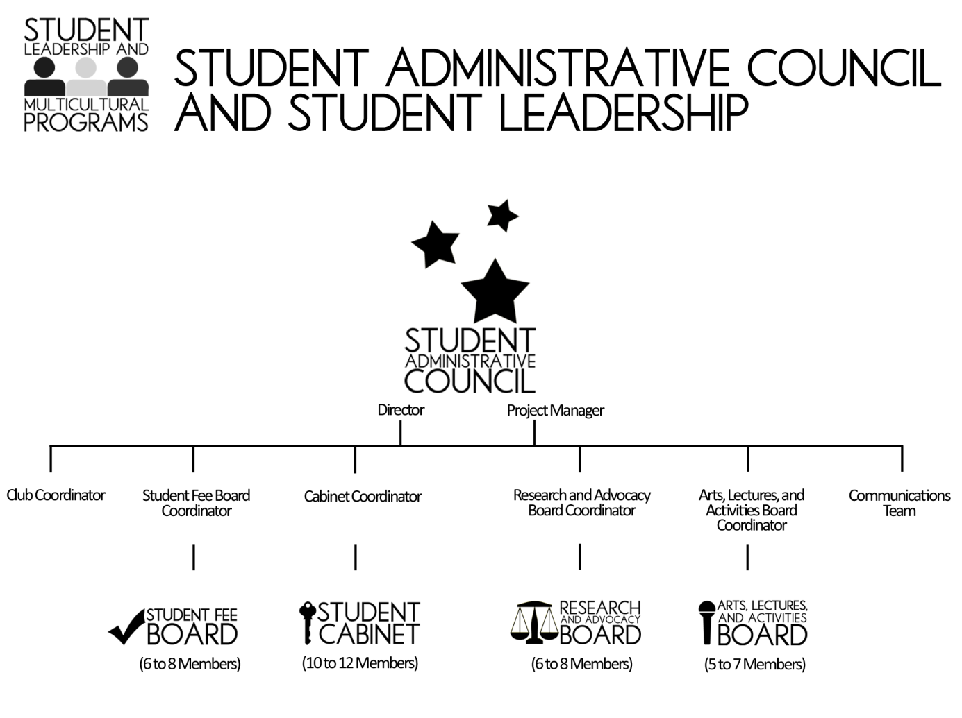

AVAILABLE STUDENT LEADER POSITIONS

2. The Student Fee Board (SFB) consists of 6 – 8 students who meet Mondays and Wednesdays from 2 – 4 p.m.; fall, winter and spring quarters. These students are responsible for allocating more than one and a half million dollars in fees including Service and Activity Fees, Universal Technology Fees and Student General / Roll-over Funds. Throughout fall quarter, the SFB learns the policies, procedures, guidelines and laws that govern fee allocation. Due to their extensive knowledge of the college budget and campus procedures, throughout the year these students are often asked to participate in projects and initiatives that help the college make important financial decisions.

3. The Student Cabinet (Cabinet) consists of 10 – 12 students who represent the student body by serving on key campus committees. These committees discuss and act on significant issues that face our campus, thereby shaping college policies and procedures. Campus committees are primarily made up of college faculty, administrators and staff with a few student members. Students contribute their opinions, ideas, and insights allowing the college to create student focused solutions to campus concerns and issues. Cabinet members develop close working relationships with NSCC staff, faculty, and administration during their time in office. A Cabinet member may serve on more than one committee and is expected to work about 8 – 12 hours a month, including Cabinet meetings every Thursday from 4 – 5 p.m.

4. The Research and Advocacy Board (RAB) consists of 6 – 8 students who develop and implement a variety of activities designed to solicit feedback from the student body about their desires, wants and concerns. RAB uses the information they collect from students to form initiatives and action plans aimed at addressing students’ interests and concerns. RAB works with campus and district administration, state legislatures and community leaders to enact decisions, policies and procedures that serve the best interests of the student body. RAB meets Monday and Wednesday from 2 – 4 p.m.

5. The Arts, Lectures, and Activities Board (ALA Board) consists of 5 – 7 students who plan and implement an array of lectures, performances, cultural presentations and events for the campus community. The purposes of these events are to promote student engagement, build community and foster a rich intellectual, educational, and cultural campus life that reflects our campus’ values. ALA meets Tuesday and Thursday from 4 – 5 p.m.

6. The Communications Board (CB) consists of 2 – 3 students who work to create a diverse and engaging student body. The Board is in-charge of ensuring the visibility of Student Leadership activities through social media and marketing efforts. The Board regularly interacts with students on campus and cultivates an inclusive student body. Communications Board members must have strong writing skills.

TO BE ELIGIBLE FOR THESE POSITIONS YOU MUST:
- New students are welcome
- Plan to be a student at North fall ‘13, winter ‘14 and spring ‘14
- Have and maintain a minimum 3.0 cumulative GPA
- Have demonstrated leadership ability on campus and/or in their community
- Have good written and oral communication skills (proficient in speaking & writing English)
- Be able to attend mandatory training sessions on the following dates:
  - Sept. 10 – 12 (9 a.m. to 4 p.m.)
  - Sept. 16 – 20 (9 a.m. to 4 p.m.)

WORK HOURS
In determining which position to apply for, please note the mandatory work hours below. For example, if you wish to be considered for a position with the Student Fee Board, you must be available to work every Monday and Wednesday from 2 – 4 p.m. fall, winter and spring quarters.
- Student Fee Board: 4 – 5 hours a week, attend mandatory meetings every Mon. and Wed. from 2 – 4 p.m.
- Cabinet: 8 – 12 hours a month, individual committee times vary but generally occur in the afternoons and meet 1 – 2 times a month. In addition, the Cabinet meets every Thursday from 4 – 5 p.m.
- Arts, Lectures and Activities Board: 5 – 10 hours a week, attend mandatory meetings every Tues. and Thurs. from 4 – 5 p.m. Additional morning and afternoon hours as arranged.
- Research and Advocacy Board: 4 – 5 hours a week, attend mandatory meetings every Mon. and Wed. from 2 – 4 p.m.
- Communications Board: 2 – 4 hours a week tentatively, must commit to attending mandatory meetings every Wednesday from 2 – 4 p.m.

MANDATORY TRAINING
Students hired for any of these positions are required to attend job orientation and training on the dates listed below. You will be paid an hourly wage for all required trainings. If you have concern about your ability to attend any of these training dates, please inform hiring committee at time of interview.
- Sept. 10 – 12 Mandatory Orientation / Training (9 a.m. to 4 p.m.)
- Sept. 16 – 20 Mandatory Orientation / Training (9 a.m. to 4 p.m.)

HOW TO APPLY
Complete and submit an official application form. Be sure to sign and to indicate the position you seek. You are welcome to submit a resume in addition to your application.
Applications will be evaluated on the quality of writing and the thought and care that goes into each component. The application must include the following:
- Cover Letter addressing how your personal and professional characteristics and experience meet the stated requirements, the knowledge, skills and abilities required for the specific position to which you are applying.
- A 1-2 page document that addresses all three of the following questions:
1. What interests you most about serving on a branch of Student Leadership?
2. Why does diversity matter today? Why is social justice work important to you?
3. If selected, what do you most hope to gain, learn and contribute?
*All applicants selected for interviews may be asked to conduct a project or activity to help the committee evaluate your skills and abilities. If the committee chooses this route then you will be given specific instructions and guidance as to the requirements for this task.
*Applicants are invited to submit any additional materials they believe provide evidence of their qualifications and commitment to serve. Examples might include: writing samples, videos, reference letters, etc.
Applicants may download an official application form at https://studentleadership.northseattle.edu/

Questions should be directed to 206.934.3643 or by e-mail at jeffrey.vasquez@seattlecolleges.edu.

2013-2014

STUDENT LEADERSHIP APPLICATION form
Applicant Information
Full Name:
Student ID:
Email: | Phone: ( ) |  | Cell: ( )
Current Address:
City: | State: |  | ZIP Code:
Position you are applying for:
Employment / volunteer work HIstory
- Employer Name:
E-mail: | Phone: ( ) |  | Duration of Employment:
Employer Address:
City: | State: |  | ZIP Code:
Position: | Starting salary: |  | Ending Salary:
- Employer Name:
E-mail: | Phone: ( ) |  | Duration of Employment:
Employer Address:
City: | State: |  | ZIP Code:
Position: | Starting salary: |  | Ending Salary:
- Employer Name:
E-mail: | Phone: ( ) |  | Duration of Employment:
Employer Address:
City: | State: |  | ZIP Code:
Position: | Starting salary: |  | Ending Salary:
Military service (if applicable)
Branch:
From: | To:
Rank at discharge: | Type of discharge:
If other than honorable, please explain discharge:

education
High School: | From: | To:
Location: | Graduate: Yes No (If No, please explain)
College: | From: | To:
Location: | Graduate: Yes No (If No, please explain)
Location: | Degree:
Other education or training, please describe:

2013-2014

STUDENT LEADERSHIP APPLICATION form
References
1)Name:
E-mail: | Contact Phone: ( )
Association:
2)Name:
E-mail: | Contact Phone: ( )
Association:
3)Name:
E-mail: | Contact Phone: ( )
Association:
disclaimer and signature
I certify that my answers are true and complete to the best of my knowledge.
If this application leads to employment, I understand that false or misleading information in my application or interview may result in my release.

Signature of applicant | Date

REFERENCES
Name:
Relation:
Phone:
Email:

Name:
Relation:
Phone:
Email:

Name:
Relation:
Phone:
Email:

